Shell scripting

1. Different types of shells that our system can support

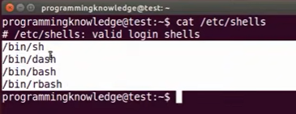

sh- born shell which is the original shell for unix like environments

bash- born again shell

1. where the bash is located

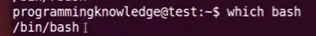

1. to create a file use command touch hello.sh
2. read and write permissions for you, read and write permissions for group and read only for others ( for a hello.sh file)

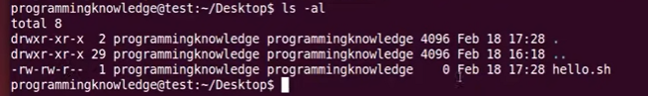

1. shebang or hashbang and location of bash

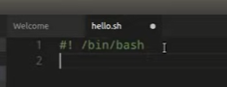

1. 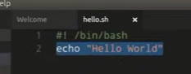
2. File does not have executable permission

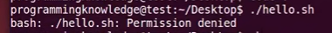

1. To make the file executable use the below ones

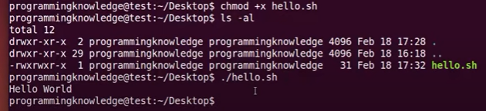

1. Comments

Whenever we write a line of code with hash (#)

1. System variables: maintained by unix operating system. The variables start with capital are system variables most likely. User defined variables are defined by ours generally starts with lowercase most likely
2. System defined variables

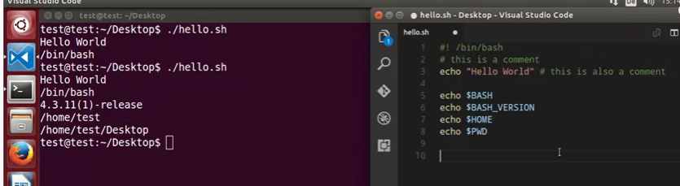

1. User defined variables
2. Variable number does not start with number see below last example

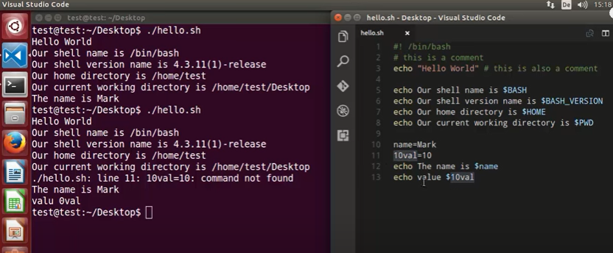

1. 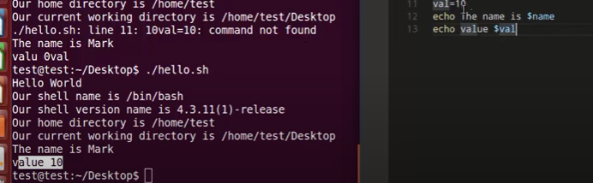
2. Whenever we want to use the input from terminal use the command “read”
3. 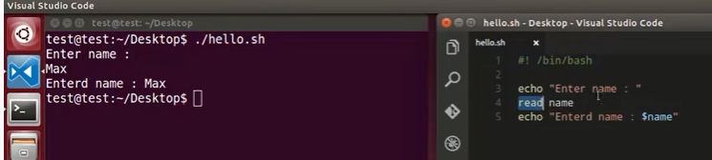

DON’T PRESS ENTER AFTER ENTERING THE NAME

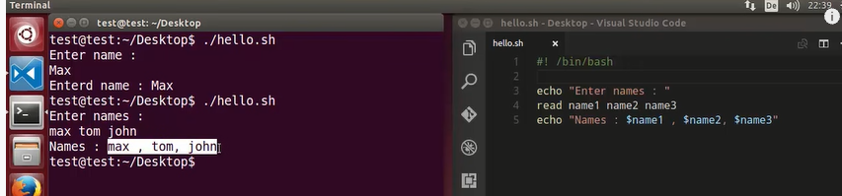

1. read –p which allows to enter the input in the same line

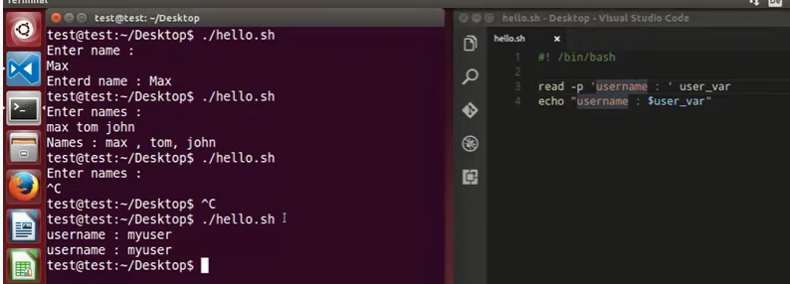

1. For password related things if you don’t want to show them typing use flag “ read -sp”

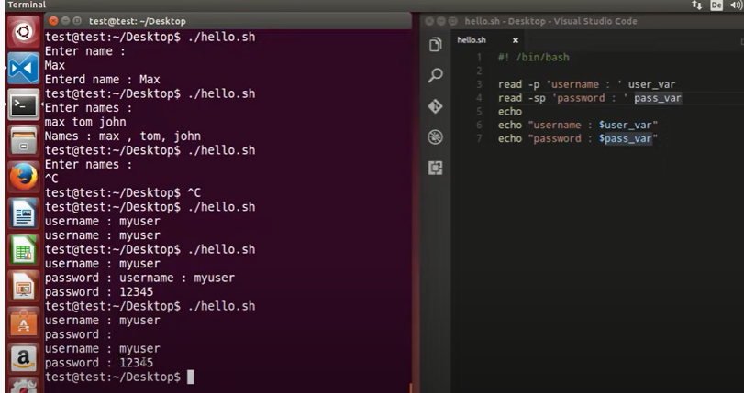

1. If you want to allow multiple inputs and save them inside the array

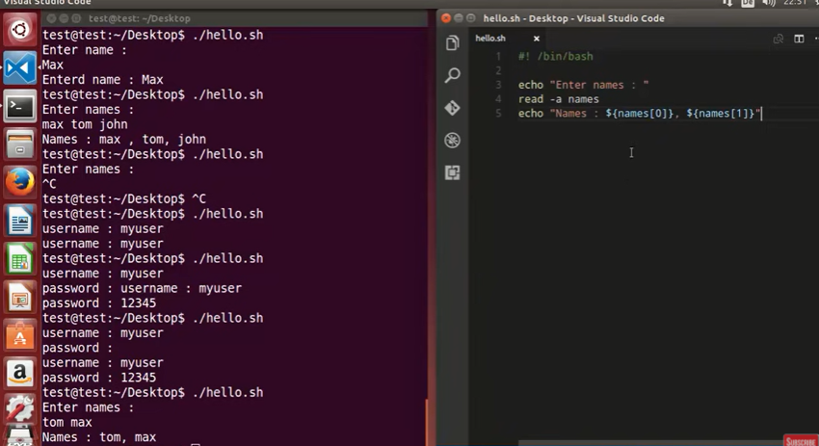

1. After read if you don’t define any variable . Default variable in which input will be stored is Reply
2. Pass arguments to a bash script
3. 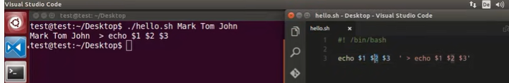

From the above screenshot we are going to pass through arguments from command line ( mark tom john ) after entering the ./hello.sh we need to give the arguments manually

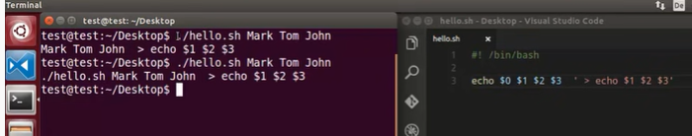

1. ‘’$@” will store the arguments in the array

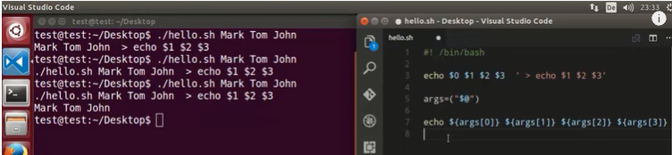

1. In the above in the 7th line if you delete the args[3] we will get the same result

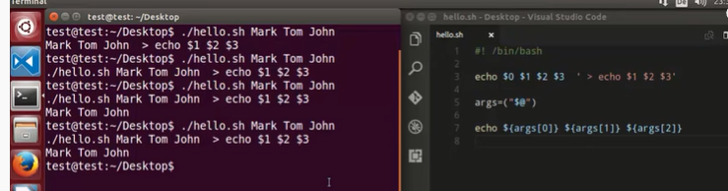

1. 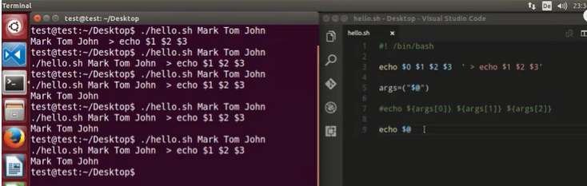
2. 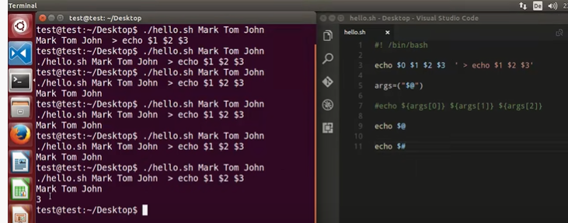

If statement

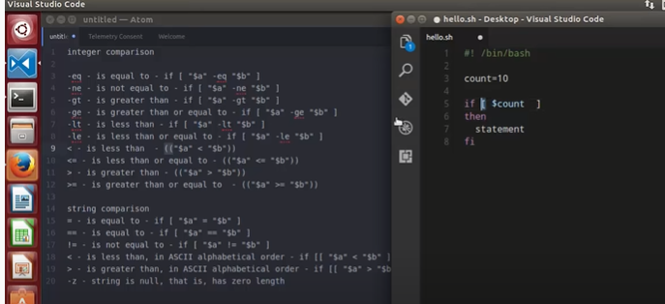

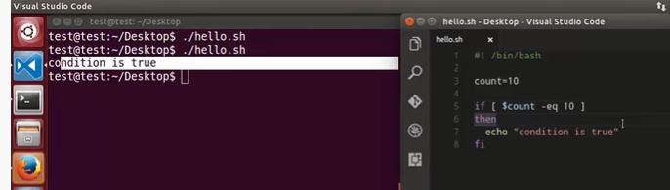

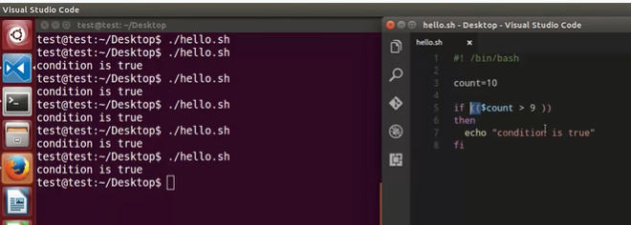

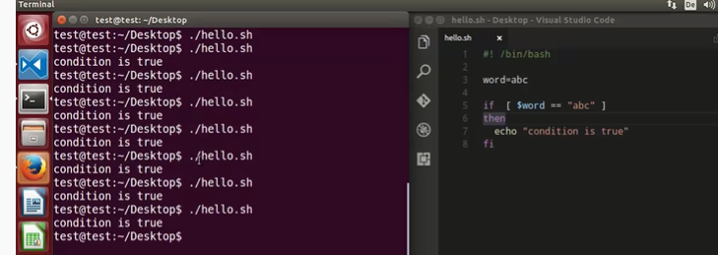

With respect to above in the 5th line if you give ONLY single “=” then the above one will also work

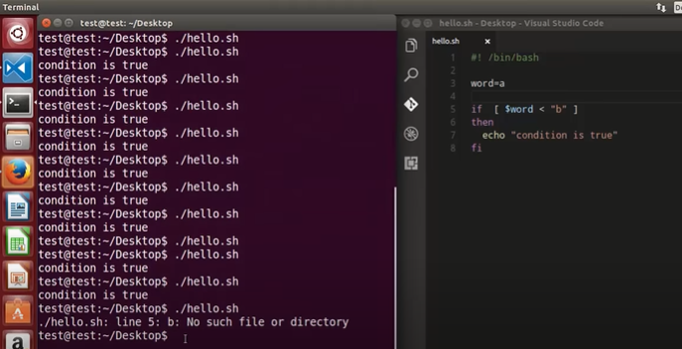

No such file or directory

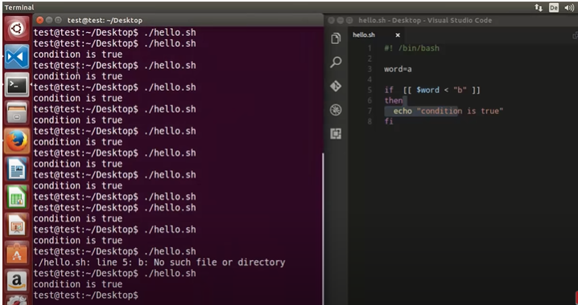

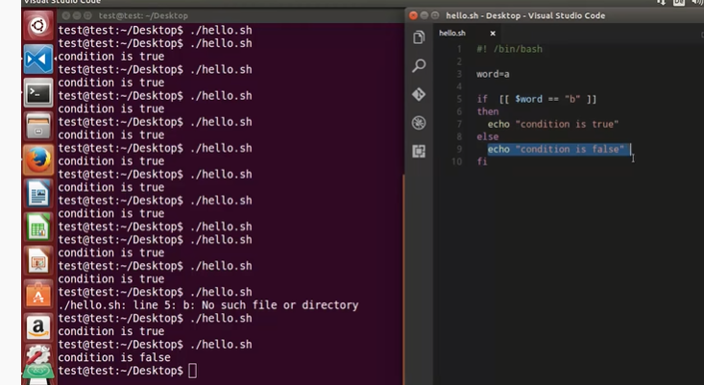

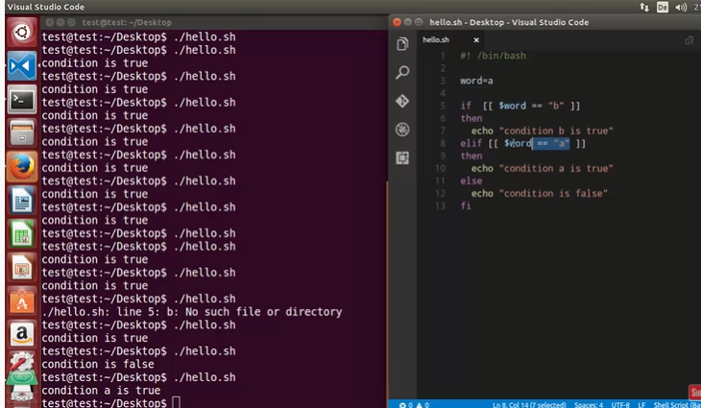

File test operators

\c and –e is used to keep the cursor on the same line

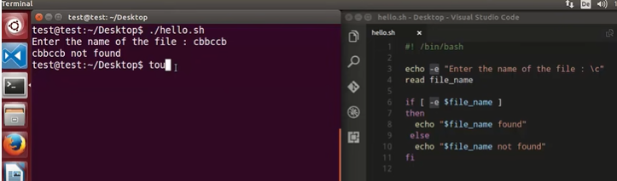

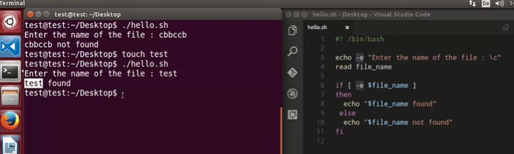

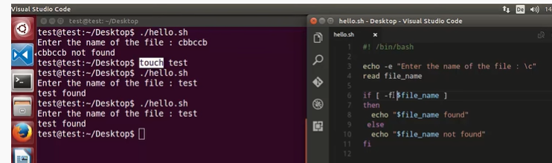

In the above screenshot 6th line –f is used to to know whether the file is present or not

For directories use –d

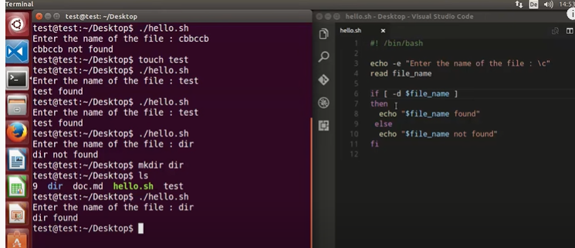

If you want to find out block special files use flag –b and for character special file use –c

If you want to check whether the flag is empty or not use the flag –s

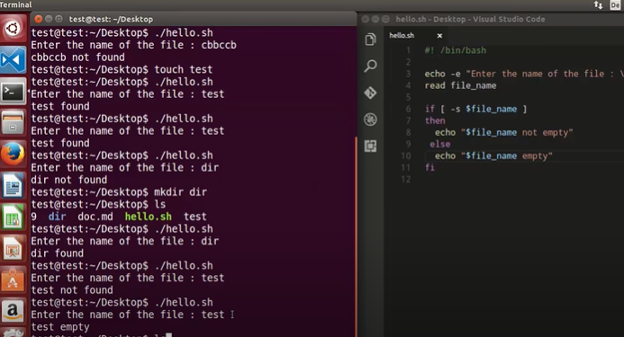

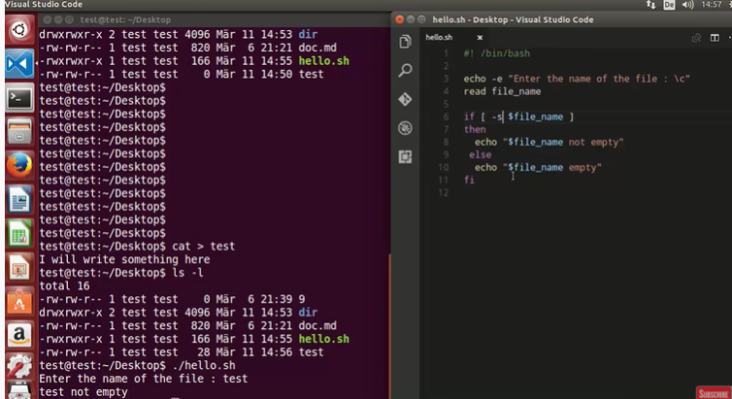

How to append output to the end of text file

-w is used to know if the file has write permissions or not

To come out of cat/shell scripting use ctrl+d

cat >> (>>is used to append output to the end of text file)

cat > (< the file will be overridden)

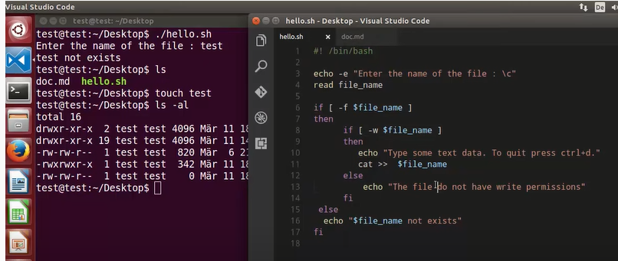

Now we have created the test file remove the write permissions for test file

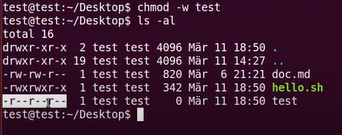

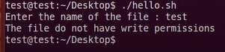

Give write permissions for test file

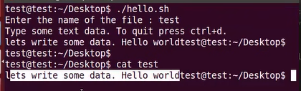

 Logical 'AND' Operator

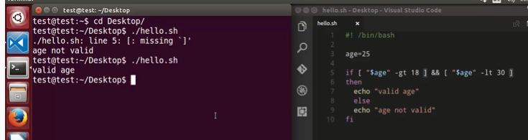

-a is && with respect to line number 5

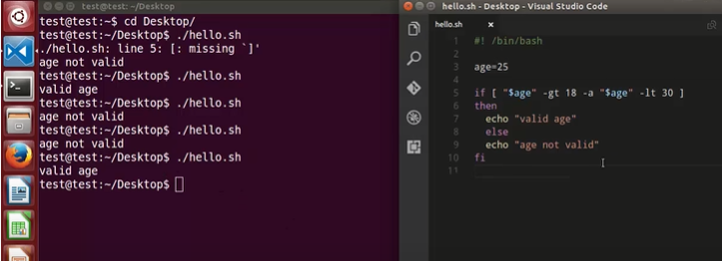

Logical 'OR' Operator

||is or operator

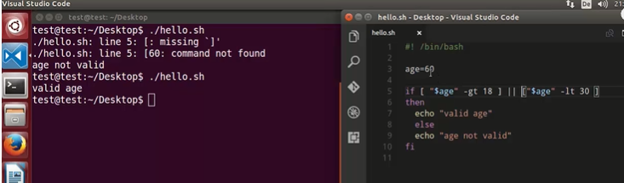

-o is “or” for operator

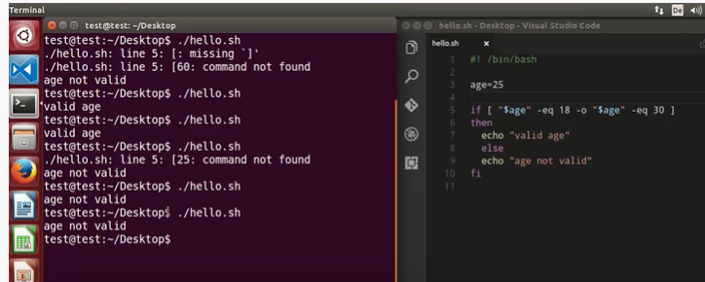

 Perform arithmetic operations

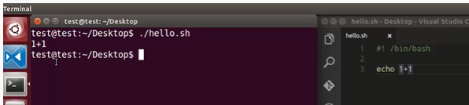

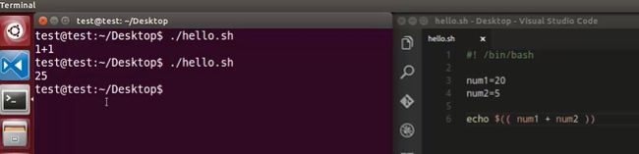

Num1+num2

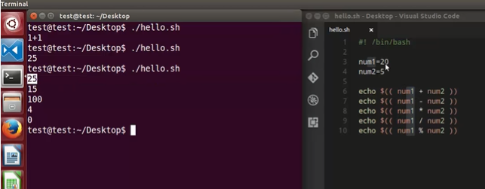

Remainder is o for (20/5) the same we see above output

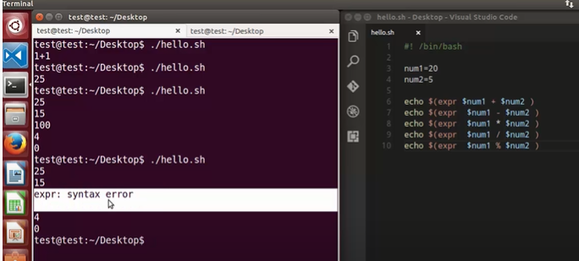

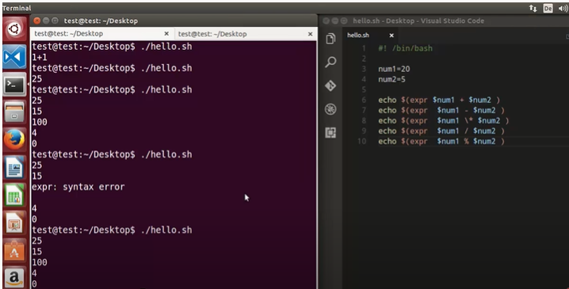

Floating point math operations in bash | bc Command

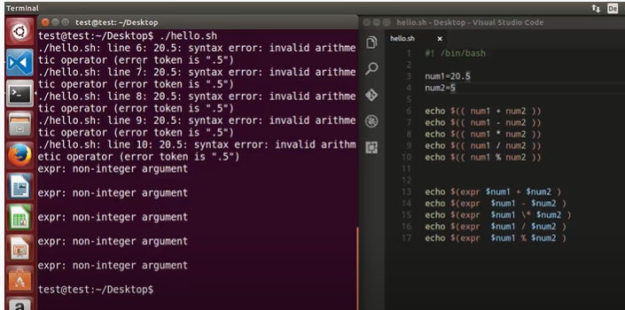

man bc will give how to use the floating variables

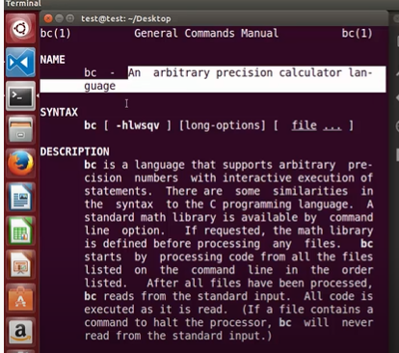

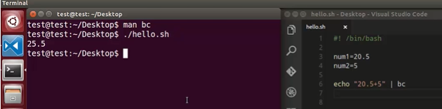

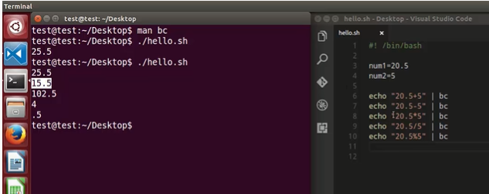

In the above screenshot division is not giving the correct answer so please see below

scale

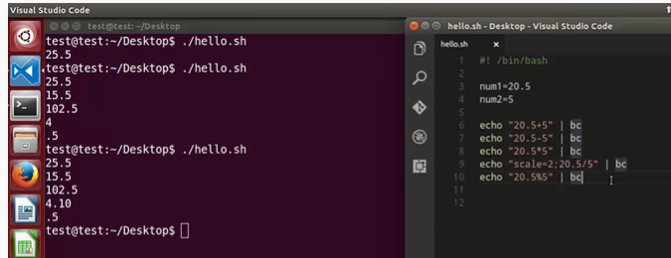

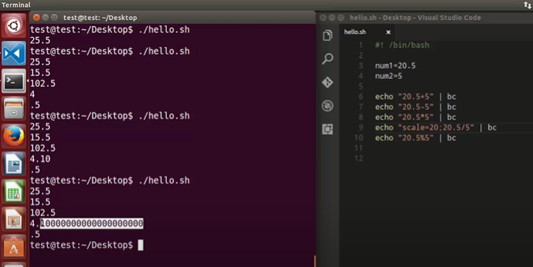

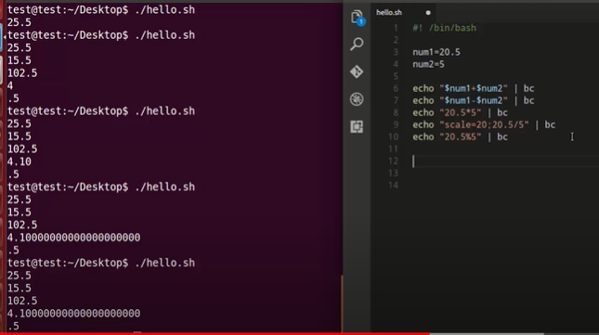

Square root operations

bc –l

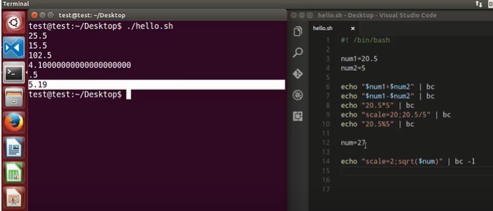

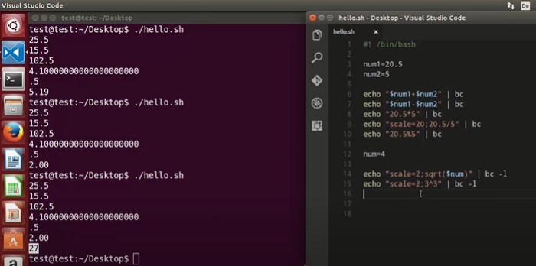

3power3

The case statement

Basic syntax for case statement

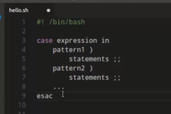

We have NOT given any vehicle type

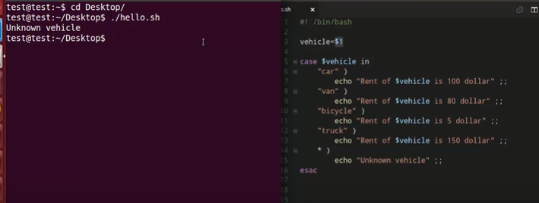

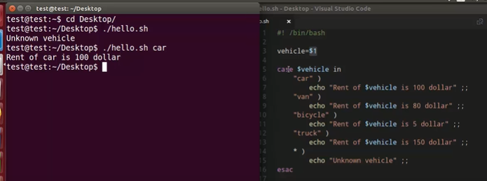

“? “is if user inputs some special characters then print that corresponding value

‘’*” Will wait for more than one character

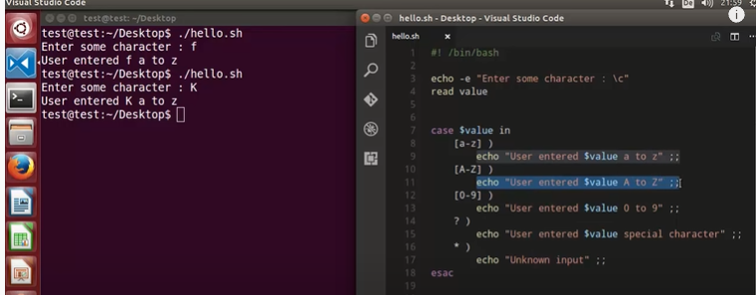

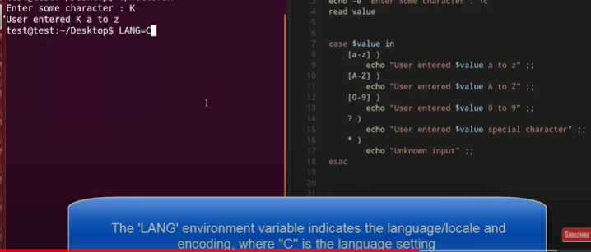

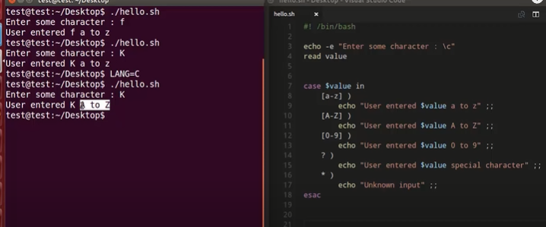

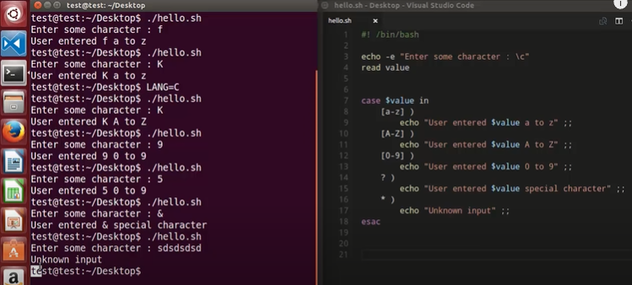

Array variables

Bash will support single dimensional ones

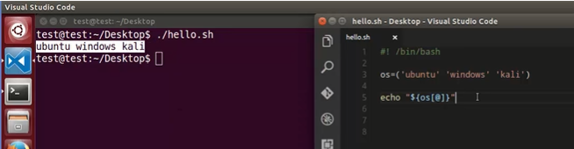

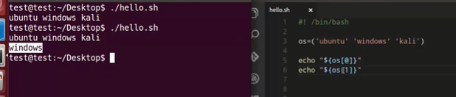

Which will print the indexes of an array with respect to line 7

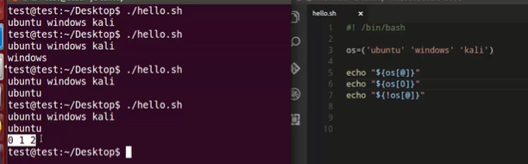

Length of an array

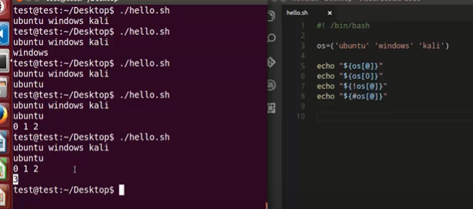

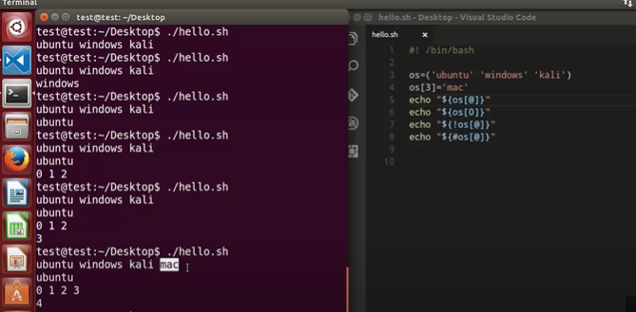

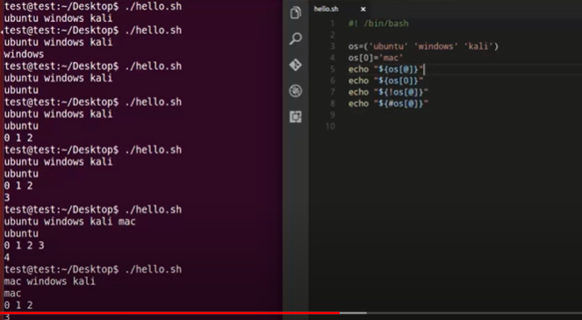

We can change the array order index as shown above

Removing from index

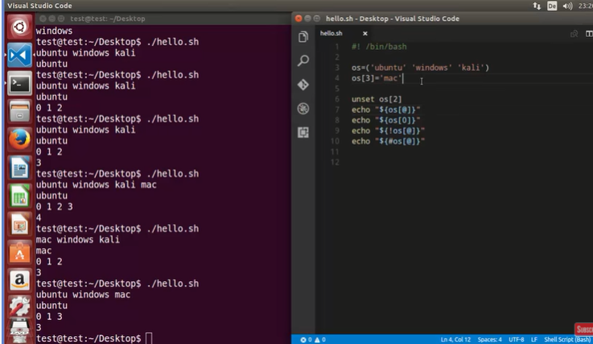

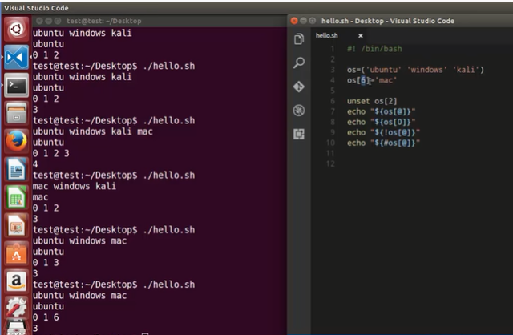

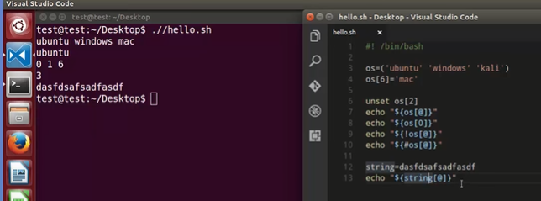

WHILE Loops

If you want to execute the list of commands repeatedly use below one

Syntax

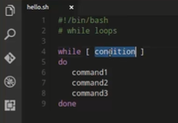

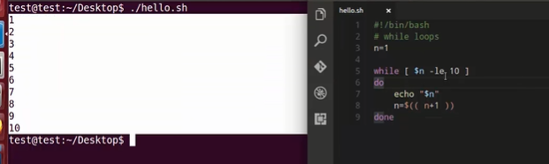

1 is less than or equal to 10 then execute value 1 and again it will increment the value by 1 so total becomes 2 and again 2 is less than or equal to 10 then execute value 3 and again it will increment the value by 1 so total becomes 3

In the above screenshot we can use n+1 or n ++ (post increment)

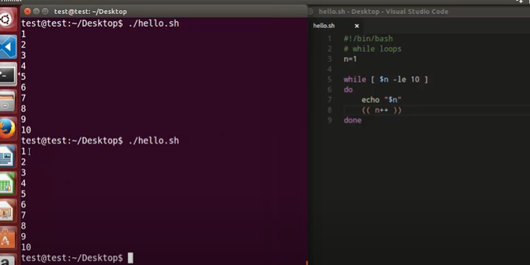

Or ++n (pre increment )

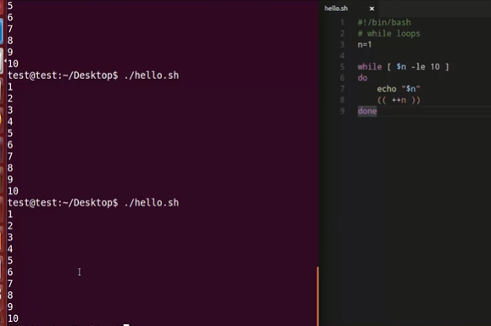

Or we can give below

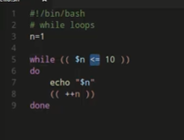

using sleep and open terminal with WHILE Loops

sleep is equal to 1 then while printing the values it will wait for one second print the next value and so on…

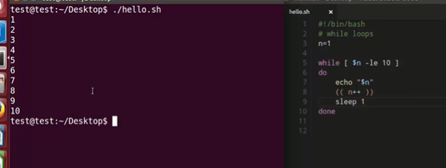

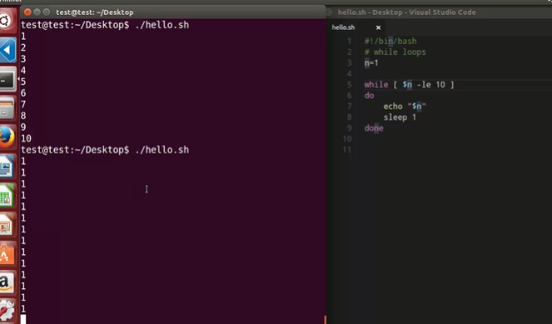

The value 1 will print always unless will forcefully shutdown by using ctrl+c

How to open the terminal

It will open the gnome terminal three times

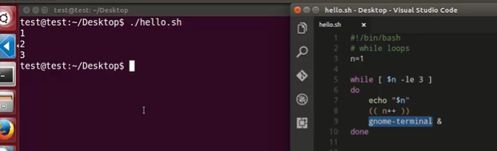

Read a file content in Bash

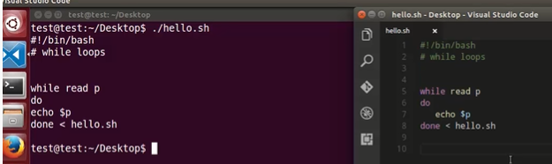

The content of cat command is the input for the while loop

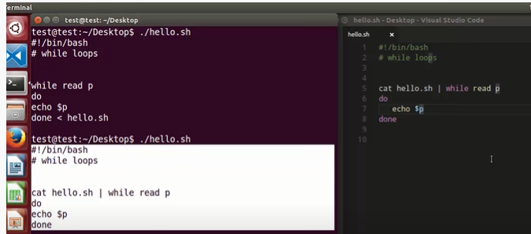

IFS- Internal feel separator and it is used by the shell to determine how to do word splitting

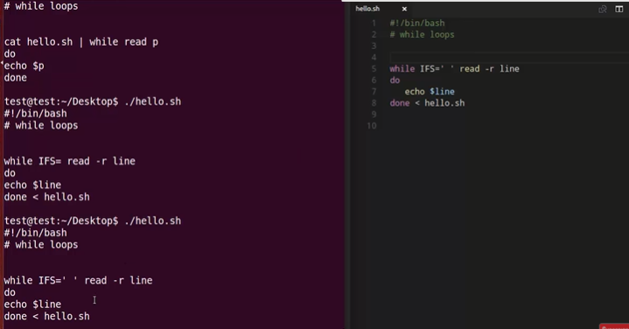

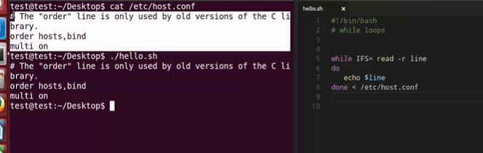

UNTIL loop

Until loop is slight different from while loop

Sysntax

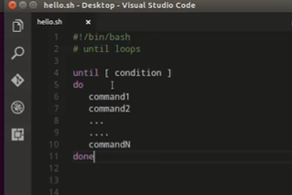

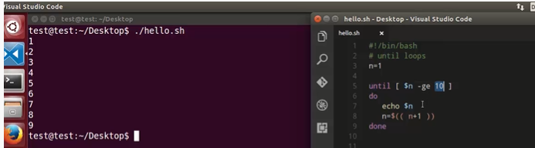

FOR loop

syntax

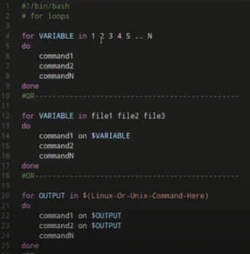

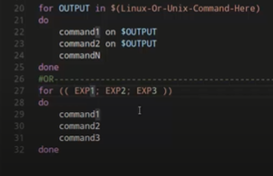

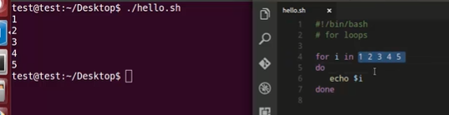

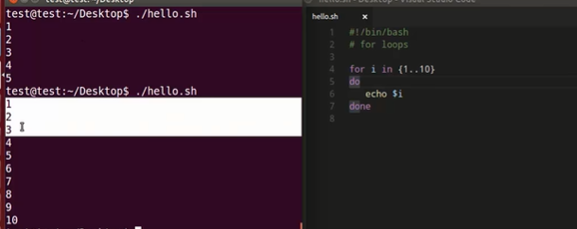

For loop incremental

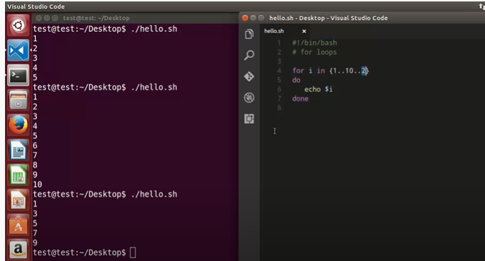

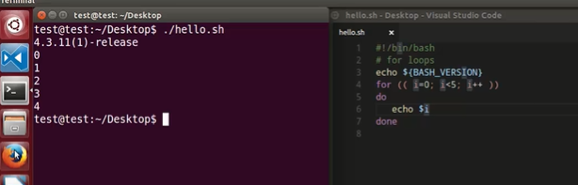

use FOR loop to execute commands

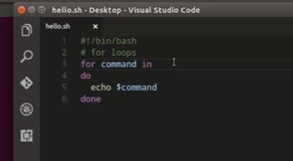

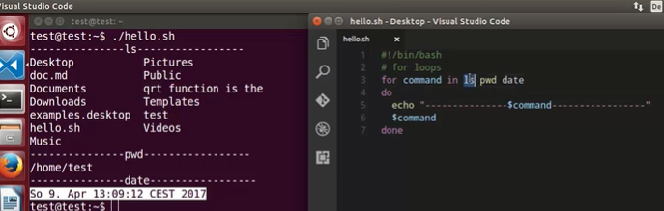

If you want to know all directories “-d” in the desktop use the for loop

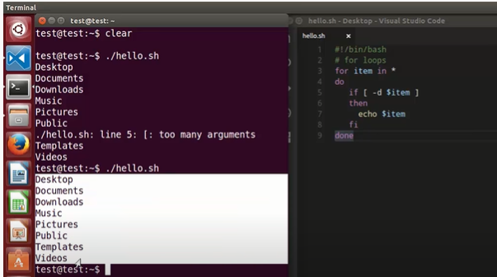

And If you want to know all files use the “-f” in the desktop

Select loop

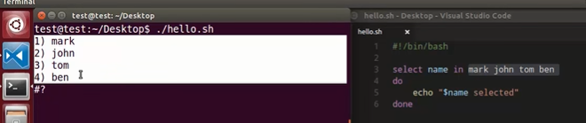

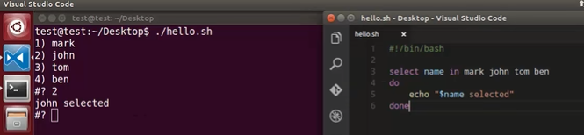

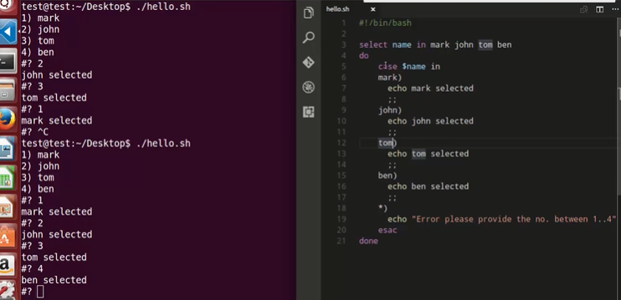

 Break and continue

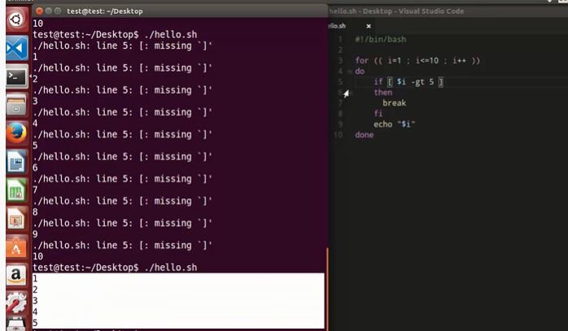

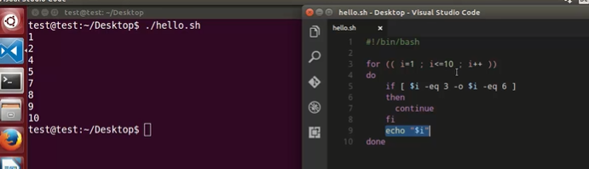

Functions

Function is a set of operations

Syntax

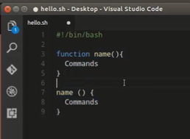

We are calling the function echo

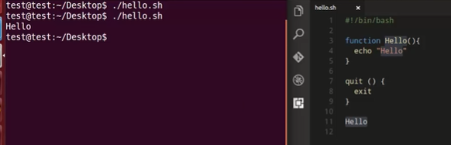

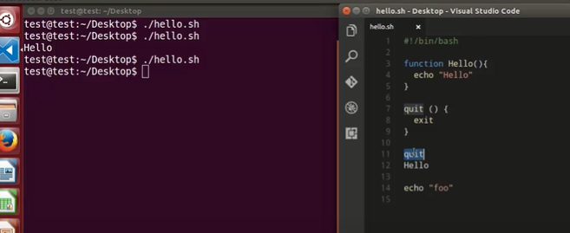

For the above one output is empty because we are not calling any function we are quitting it

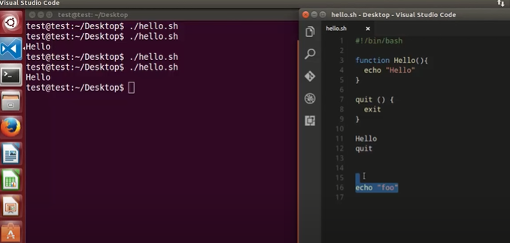

Only hello is printed NOT the foo

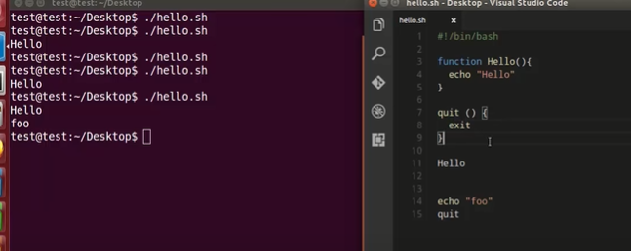

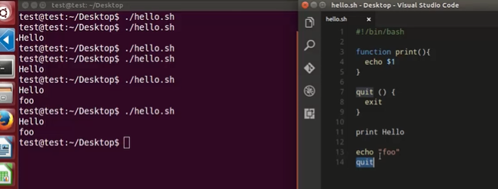

Print will call the echo and executes the hello and foo function

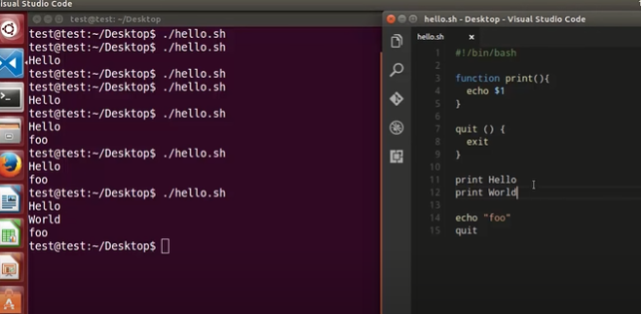

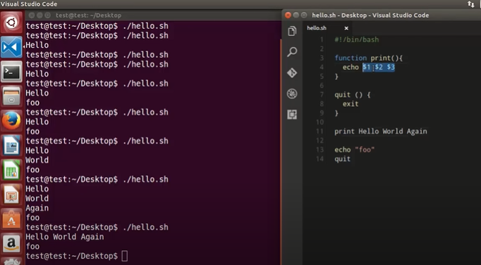

Local variables

Every variable which you declare in your script is a global variable and that means it can be accessed it anywhere in your script

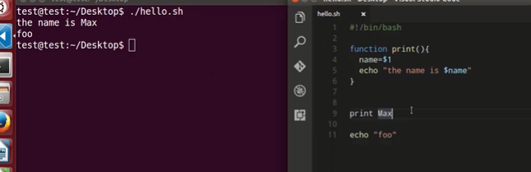

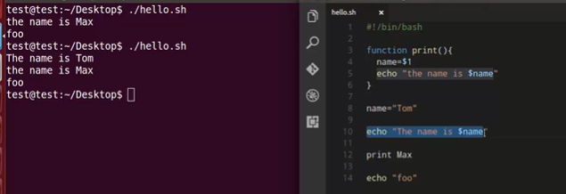

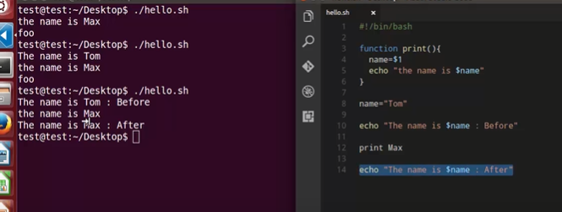

If you add a local in front of your variable then variable becomes local to the function see line numbers (3 to 5)

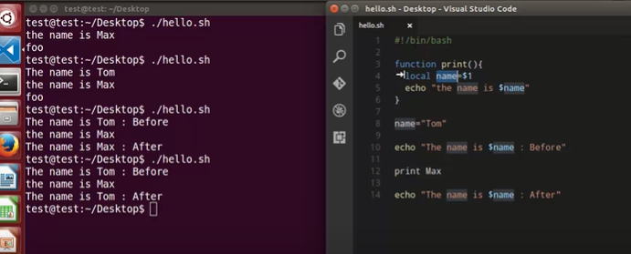

Name = ‘’Tom” is global variable

Function Example

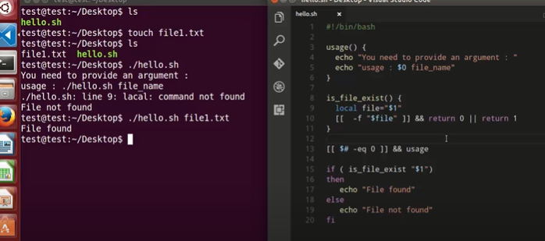

Read only command

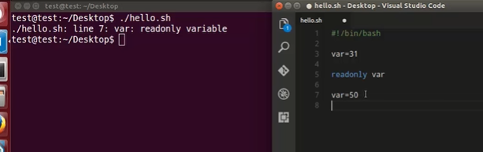

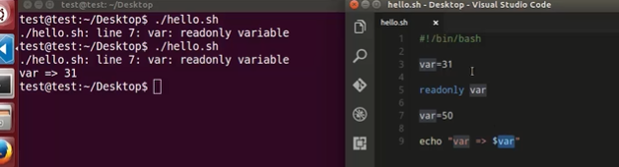

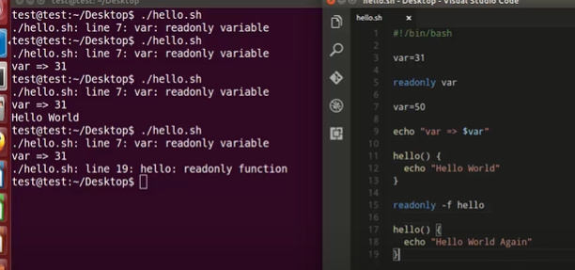

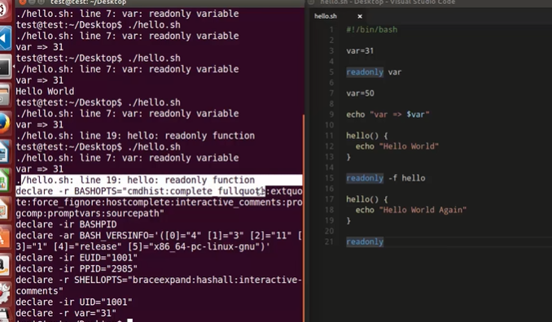

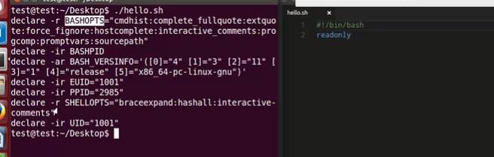

Variables read only if you want to know what they are use flag “-p”

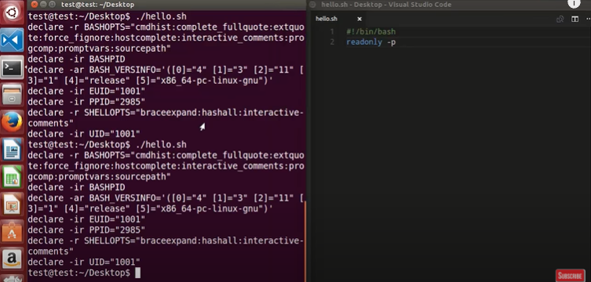

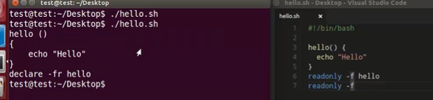

Signals and Traps

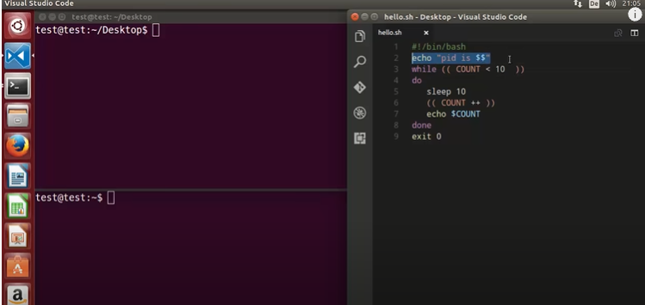

In this article, we will look at how to find a process name by its **process identification number** (PID). ... Every time a user or the system (Linux) launches a program, the kernel will create a process. A process holds execution details of the program in memory such as its input and output data, variables and so on

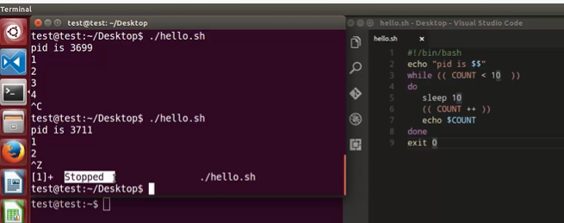

Ctrl+c or ctrl+z is used to come out of shell scripting

Which is also called control signal . Im signal term it is sig ts&tp

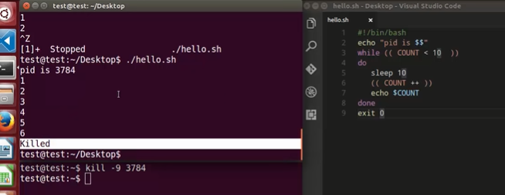

Kill -9 is used to kill the processor

Trap command is used to capture and interpret and clean it within the script

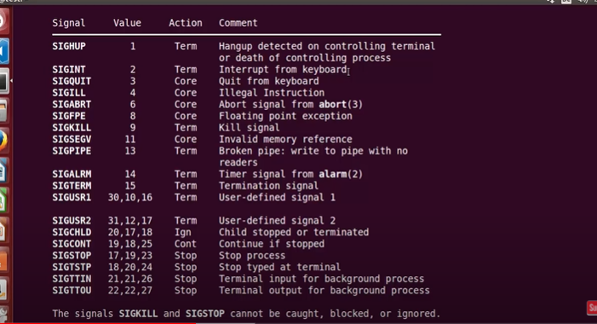

man 7 signal

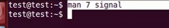

Is used to know the signals

ctrl+c is used to interrupt from keyboard see above from signal 2

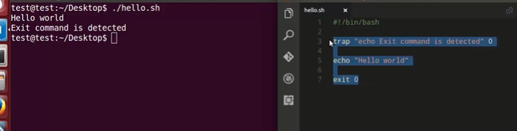

Siginit or 2

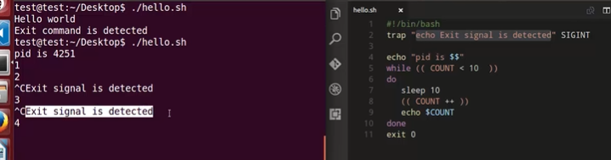

Semicolon ; is used to combine the statements

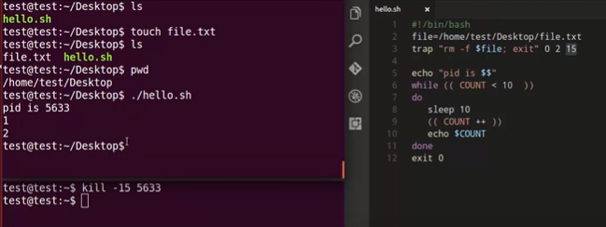

The signal is received after kill -15 5633 and the shell exit from the terminal

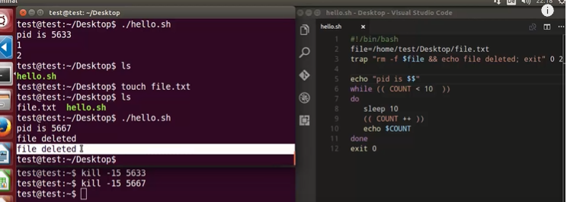

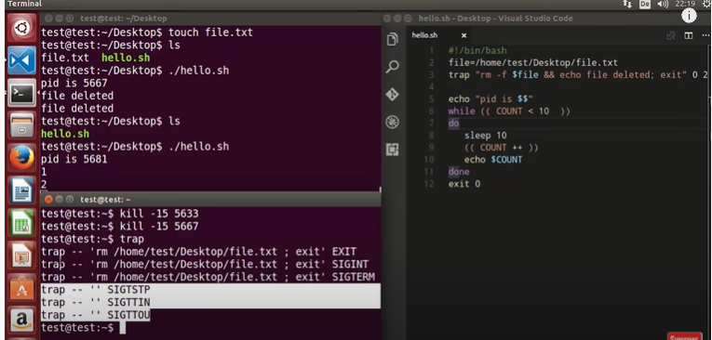

If you want to remove the trap so how do we do that

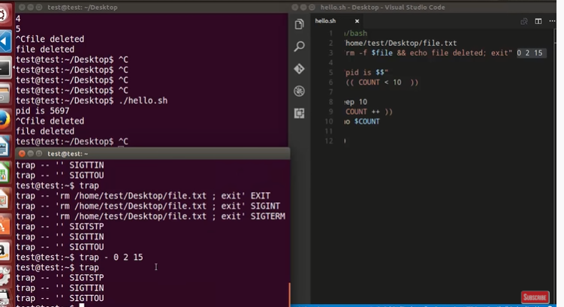

How to debug a bash script

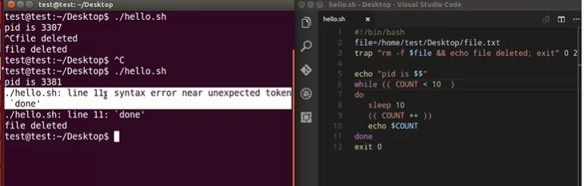

bash –x ./hello.sh

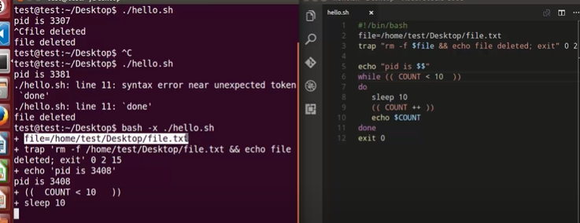

-x

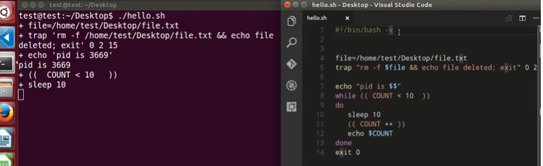

set –x is used to debug

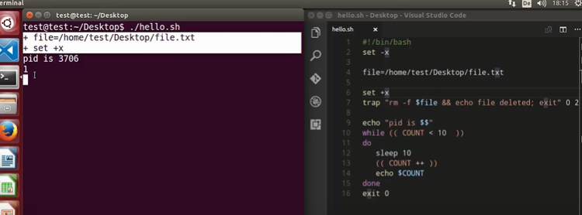

-x Is used top debug the code and +x is used to stop the debugging the code